Object Oriented Programming Lab

SPRING 2024

LAB 03



FAST National University of Computer and Emerging Sciences

Learning Outcomes

In this lab you are expected to learn the following:

• Pointers

• 2D Dynamic Memory Allocation
POINTERS

A pointer is a variable that stores an address of a memory location.

Pointer Declaration and initialization
Pointers is declared as follow.

Type* <variable Name>;

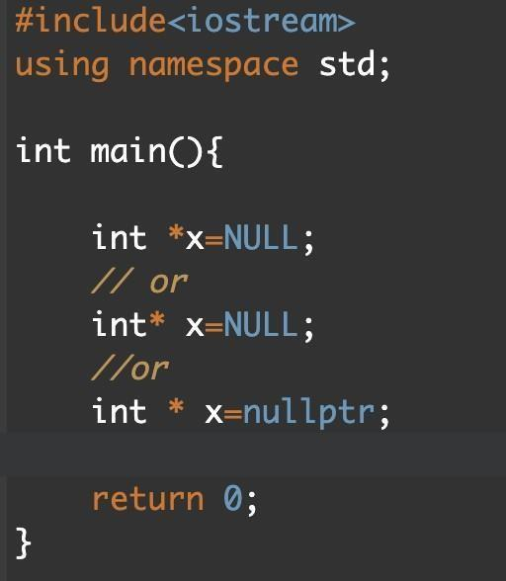

Address-of operator (&)

The ampersand, &, called the address of operator, is a unary operator that returns the address of its operand.

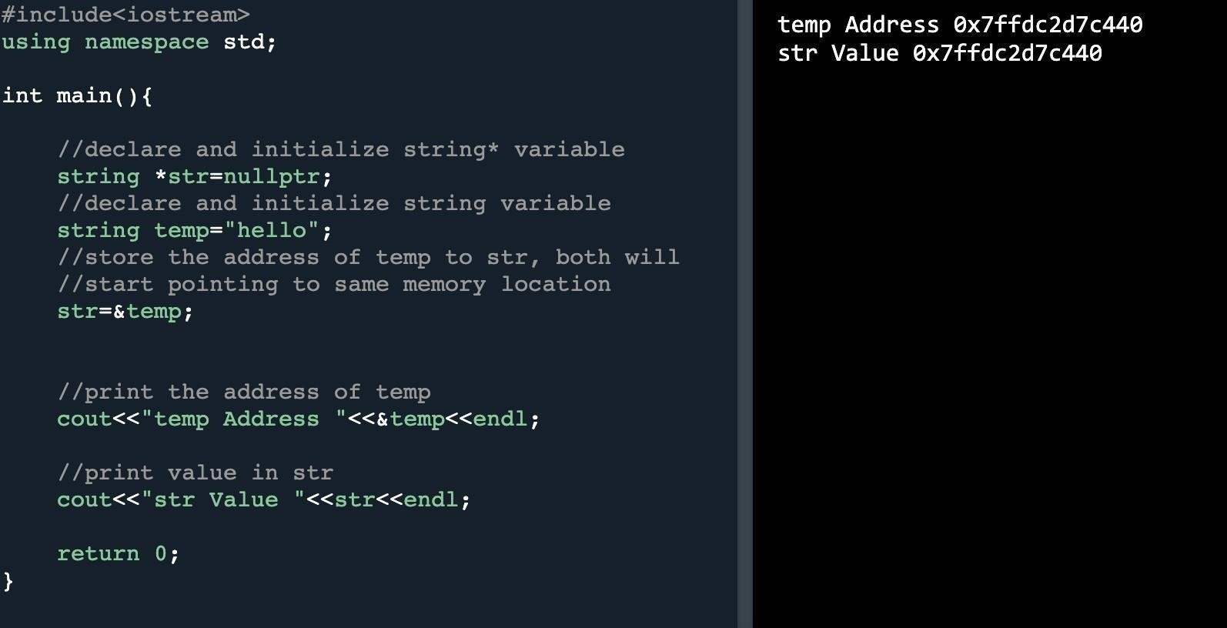

Dereference operator (*)

The unary operator * is the dereferencing operator that returns the value of its operand.

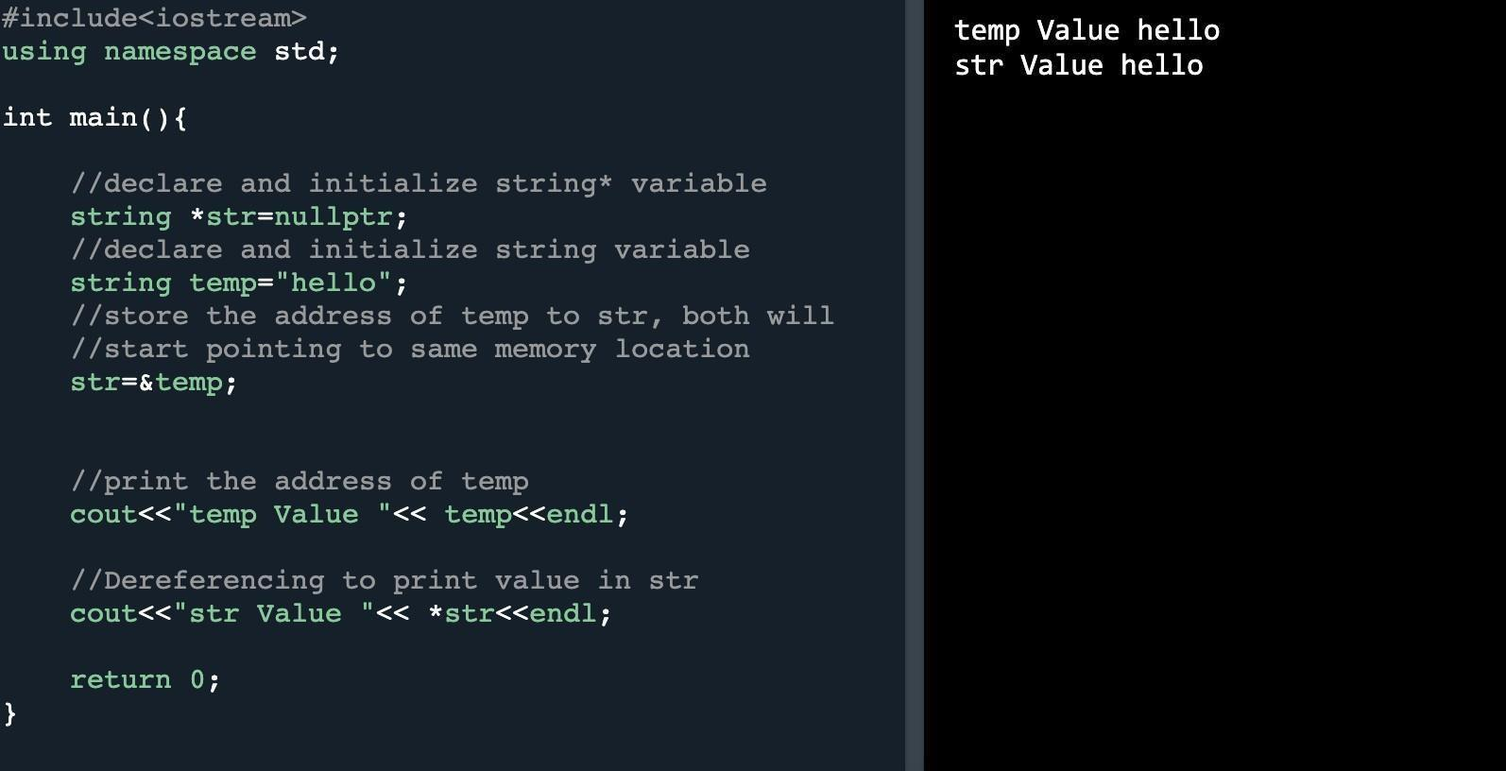
Array manipulation using pointer

The identifier of the array is a constant pointer. The elements of the arraycan be accessed using dereferencing in the following manner.

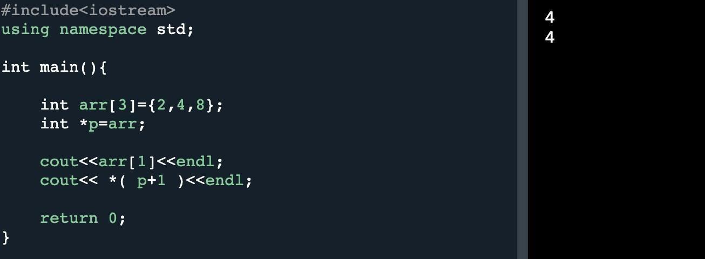

Note: You are supposed to pass the test cases for all functions.

These problems cover a range of concepts related to pointers and 2D dynamic arrays in C++, providing practical challenges for OOP students to enhance their understanding and coding skills.

Problem 1.
Dynamic Matrix Allocation:
Declare a function that takes two integers (rows and columns) as parameters and dynamically allocates memory for a 2D matrix. Initialize the matrix with random values and print its contents.

Problem 2.
Transpose Matrix:
Write a program that takes a 2D array as input and returns its transpose using pointers.

Problem 3.
Sum of Rows and Columns:
Create a program that calculates the sum of each row and each column in a 2D dynamic array. Display the results.

Problem 4.

Find Maximum Element:
Write a function that finds and returns the maximum element in a dynamically allocated 2D array. Use pointers for array traversal.

Problem 5.
Given an m x n integer matrix matrix, if an element is 0, set its entire row and column to 0's.
You must do it in place.
void setZeroes(int** matrix) {

}
Example 1:
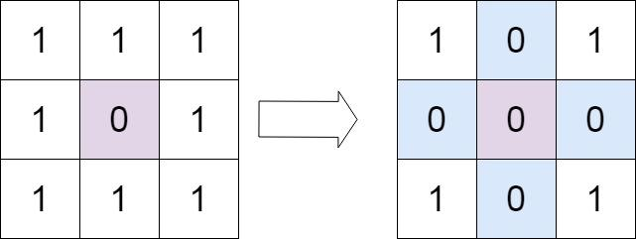
Input: matrix = [[1,1,1],[1,0,1],[1,1,1]]
Output: [[1,0,1],[0,0,0],[1,0,1]]

Example 2:
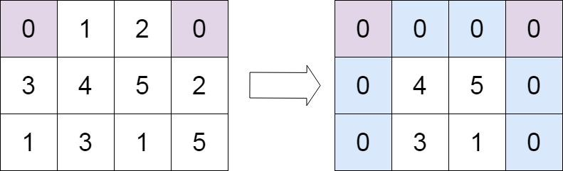

Input: matrix = [[0,1,2,0],[3,4,5,2],[1,3,1,5]]
Output: [[0,0,0,0],[0,4,5,0],[0,3,1,0]]

Submission Instructions:

1. Create a single cpp file containing all the functions of the problems and main function.
Save the cpp file as Q1.cpp.
2. Now create a new folder with name ROLLNO_SEC_LAB01 e.g. i22XXXX_A_LAB01.
3. You need to display your roll no and name before the output of each question.
4. comment out the main Function and then move to this newly created directory and compress it into a .zip file.
5. Now you have to submit this zipped file on Google Classroom.
6. If you don’t follow the above-mentioned submission instruction, you will be marked zero.
7. Plagiarism in the Lab Task will result in zero marks in the whole category.

